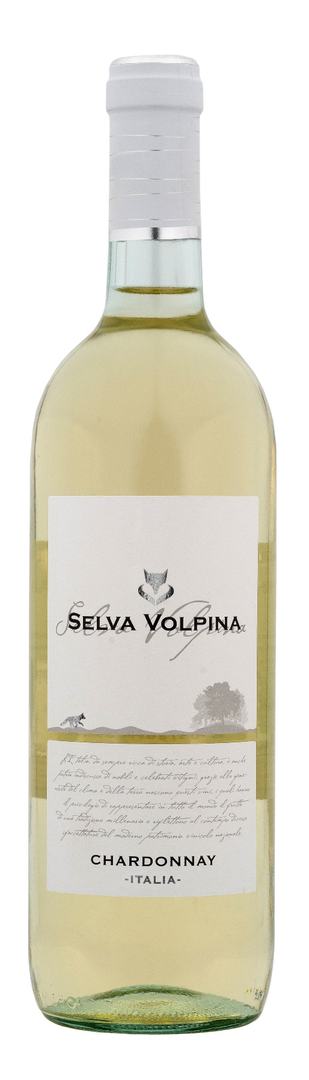
CHARDONNAY ITALIA – SELVA VOLPINA

Grape: Chardonnay 100%
Alc. Vol.%: 12
Vintage: 2025
Residual sugar g/l: 5,5
Total acidity g/l: 5,9
Production zone: Vineyards in the Central Italy
Capacity: 750ml, 1500ml

CHARACTERISTICS

Vinification: Soft pressing and cold fermentation at a controlled temperature of 18°C
Yield per ha: 16000kg
Colour: Bright straw-yellow
Bouquet: Ethereal and lightly fruity
Flavour: Pleasantly dry, smooth and round

SERVING SUGGESTIONS

Best enjoyed as an aperitif, with starters and all kind of seafood.
Serving temperature 8-10 °C
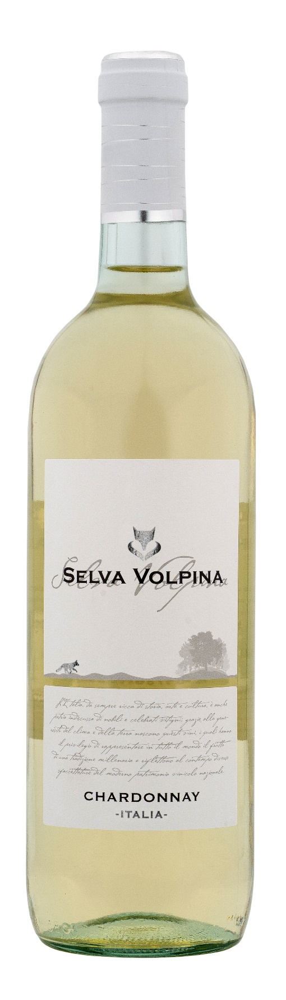
TECHNICAL INFORMATION / PALLETIZING

Size 750ml:
Article Nr. V10009A
GTIN-13 bottle 8017868003526
GTIN-13 carton 8017868002659
Closure Cork/Screwcap
Bottles / carton 6 bottles
Pallet size 80x120cm
Cartons/layer 25
Cartons/pallet 125
Kg/carton 7,2
Kg/pallet 925

Size 1500ml:
Article Nr. V10010B
GTIN-13 bottle 8017868002628
GTIN-13 carton 8017868004615
Closure Screwcap
Bottles / carton 6 bottles
Pallet size 80x120cm
Cartons/layer 14
Cartons/pallet 56
Kg/carton 13,4
Kg/pallet 790

Contains sulphites
GMO Free
Revisione 01. 14.05.2026

